Git and github Assignment - sania

1. Create a new GitHub repository.

Clone the repository to your local machine using SSH (generate an SSH key if needed, add
the public key to your GitHub account).

Already created the ssh key
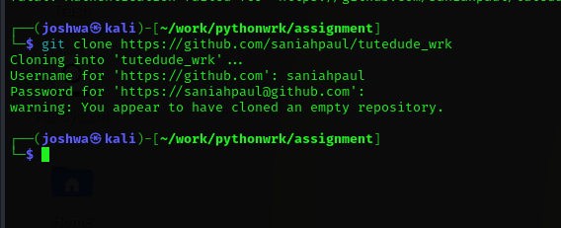
- Create a new branch named after your username (e.g., Tutedude).
- Add your Flask project files to this branch.
- Commit the changes and merge the branch into the main branch.
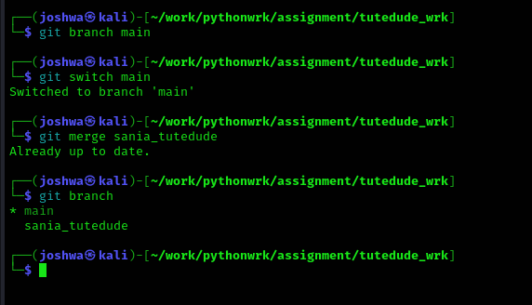
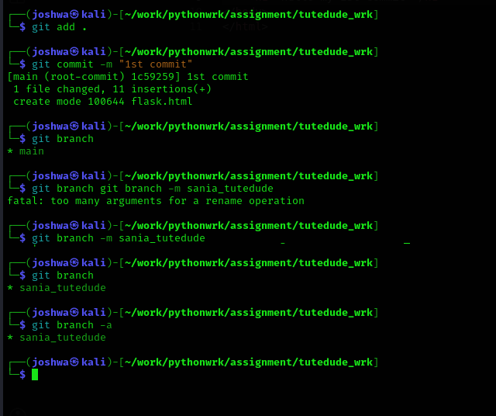

2. Create a new branch named <your_name>_new (e.g., Tutedude_new).
- Update the content of the JSON file used for the /api route in this branch.
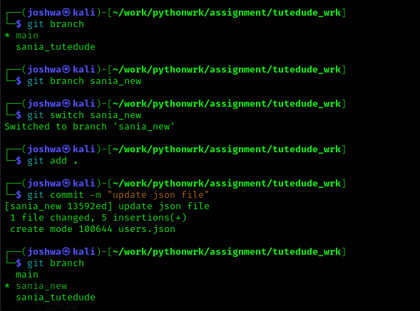
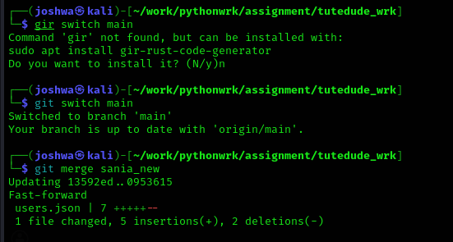

Merge conflict happened

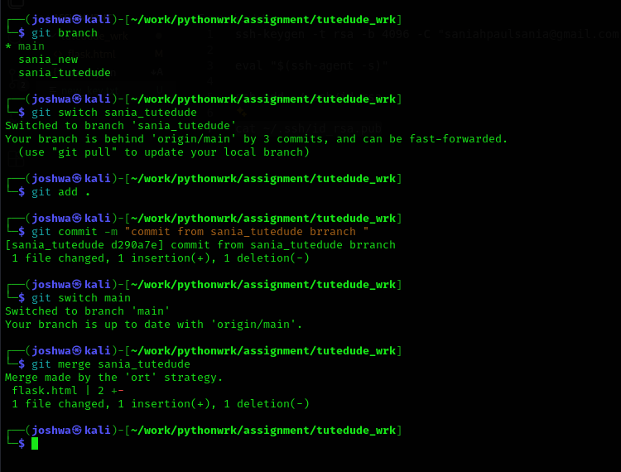

3. Branch Creation:
- Create two branches: master_1 and master_2 from the main branch.
- Feature Development in master_1:
- In the master_1 branch, create a To-Do Page in the frontend.
  - The page should contain a form with the following fields:
    - Item Name
    - Item Description

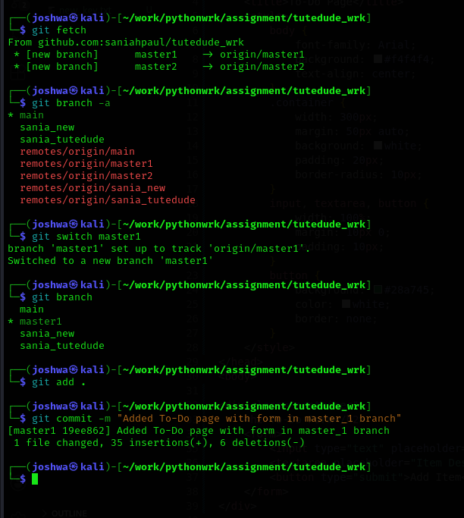

4. Enhancing the To-Do Form in master_1:
- In the master_1 branch, add the following fields to the To-Do form:
  - Item ID
  - Item UUID
  - Item Hash

